

|  |
| --- |
| WaiDATATHON  2020 |
|  |
| October 11  COMPANY NAME  Authored by: KIRTHIKKA DEVI VENKATARAM |

## Tasty dish recommendations based on personal nutrient needs

|  |
| --- |
| Nutrient Dish Recommender System The food identification system identifies the food or name of the dish served with the weightage of the dish specified by the user, calculates the nutrient value and breaks down into sub components of each nutrient.  Compiling the nutrient component, the Recommender system decides the User Preference by identifying the personal choice of the user irrespective of the health details and returns the dishes. |
| *“A Cognitive recommender identifies the nutrient value, popularity also the user’s behaviour and preference”* |
| Build a Cheeseburger  Finding the  First, ingredient descriptions in the recipe need to be matched to an appropriate entry in a nutritional database. Second, the quantity of ingredient in the recipe description needs to be converted to a standard scale (in this case, weight in grams)  The first step is to take the raw description from the source text and separate it into the amount and ingredient description  The second step is to form the ingredient-based rule with the ingredient description to the nutrient amount added to it by knowing the raw ingredient nutrients, the basic nutrients - calories, proteins and carbohydrates (Figure 1) |
| Ingredient Description    Nutrients Calculator  DATABASE -Single Ingredient Meals / Recipes and Mixed Dishes / Full Meals  Figure 1 |

Cognitive Recommender System

“An emerging paradigm of intelligent computing methodologies and systems based on cognitive informatics that implements computational intelligence by autonomous inferences and perceptions mimicking the mechanisms of the brain”



Personal Preference

Personality, Behavior, Attitude

 

Big Data Domain Expert Knowledge

Figure 2

Big Data – Data base serving the Nutrient value for the Food dish

Domain Expert Knowledge – Based on the food / dish review / popularity of the dish

Personal Preference – User’s personal attitude and health based recommendation

Three main Dimensions of a Cognitive Recommender System Figure 2—(i) knowledge-driven —which enables mimicking the knowledge of domain experts using crowdsourcing techniques;(ii) data-driven : which enables leveraging Artificial Intelligence and Machine Learning technologies to understand the Big Data generated on Open, Private and Social platforms/systems to improve the accuracy of recommendations; and (iii) cognition-driven: which enables understanding the end-users personality and Analyze their behavior and attitude over time

A frame work of the Cognitive Recommender System – Figure 3

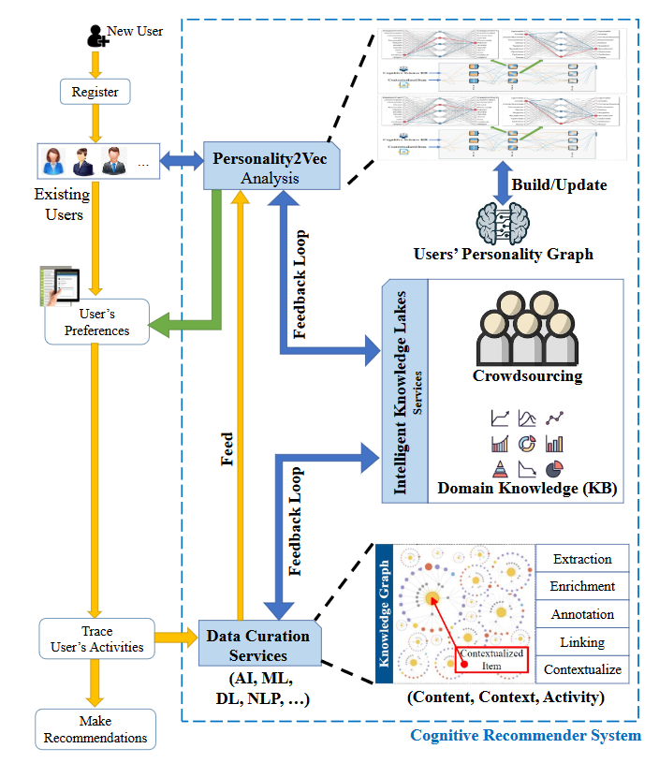

Figure 3 – Framework of Cognitive Recommender System

REFERENCES:

1. <https://ndb.nal.usda.gov/ndb/foods/lis>
2. <https://core.ac.uk/download/pdf/11552457.pdf>